MongoDB Project

- In Visual studio code, in mongodb_project, after opening mongo.js file and run in vs terminal:
node mongo.js
the result in the terminal:

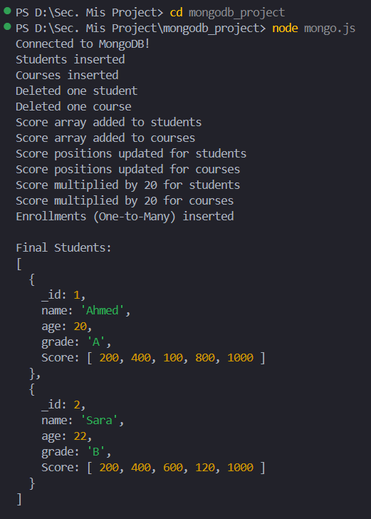
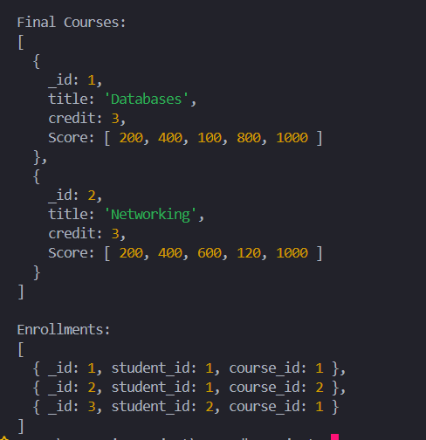

- In the power shell, run this commands line by line:
docker exec -it my_mongo mongosh
use MIS_DB

And then write the Aggregation function:

db.enrollments.aggregate([
{
$lookup: {
from: "students",
localField: "student_id",
foreignField: "_id",
as: "student_info"
}
},
{
$lookup: {
from: "courses",
localField: "course_id",
foreignField: "_id",
as: "course_info"
}
},
{
$project: {
_id: 1,
student_info: { $arrayElemAt: ["$student_info", 0] },
course_info: { $arrayElemAt: ["$course_info", 0] }
}
}
])

The result in the power shell after run the Aggregation function:

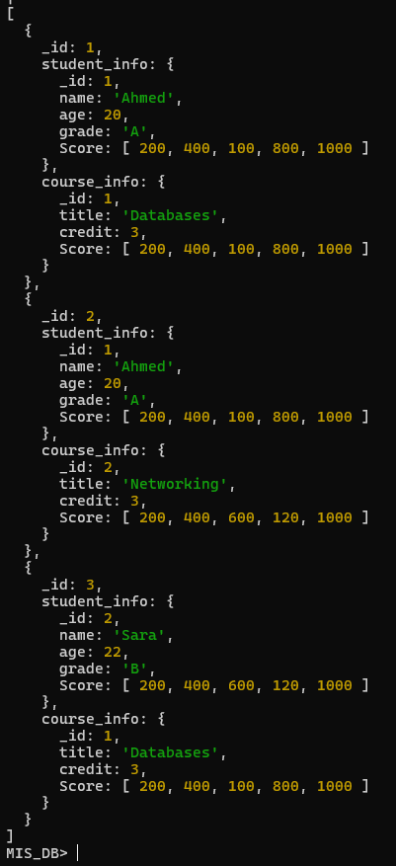

Cassandra Project

1-In Visual studio code, in cassandra_project, after opening cassandra.js file and run in vs terminal:
node cassandra.js
the result in the visual studio terminal:

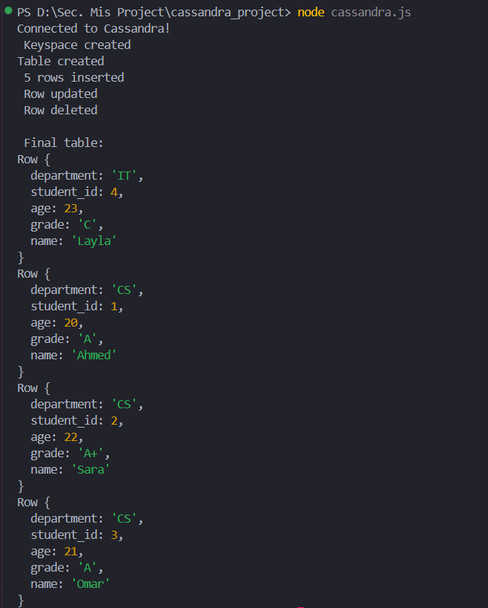
2-In the power shell, run this commands line by line:
docker exec -it my_cassandra cqlsh
USE mis_keyspace;

continue in the CMD and write (all the lines in one time):
CREATE TABLE IF NOT EXISTS students (
department TEXT,
student_id INT,
name TEXT,
age INT,
grade TEXT,
PRIMARY KEY ((department), student_id)
);

continue in the CMD and write (all the lines in one time):
INSERT INTO students (department, student_id, name, age, grade) VALUES ('CS', 1, 'Ahmed', 20, 'A');
INSERT INTO students (department, student_id, name, age, grade) VALUES ('CS', 2, 'Sara', 22, 'B');
INSERT INTO students (department, student_id, name, age, grade) VALUES ('CS', 3, 'Omar', 21, 'A');
INSERT INTO students (department, student_id, name, age, grade) VALUES ('IT', 4, 'Layla', 23, 'C');
INSERT INTO students (department, student_id, name, age, grade) VALUES ('IT', 5, 'Khaled', 20, 'B');

continue in the CMD and write (all the lines in one time):
SELECT * FROM students
WHERE department = 'CS'
ORDER BY student_id DESC;

And the result in the power shell:

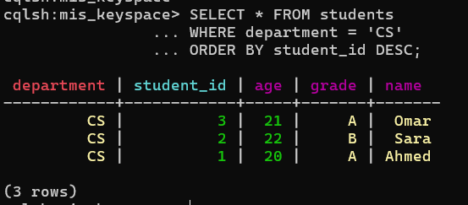

continue in the CMD and write (line by line):
CREATE INDEX ON students (grade); (if there is no index)

SELECT * FROM students WHERE grade = 'A';

And the result in the Power Shell:

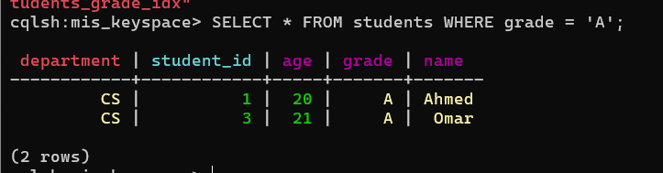
NEO4J Project

- Go to Neo4j Desktop and run the instance

2-In Visual studio code, in neo4j_project, after opening cassandra.js file and run in vs terminal:
node neo4j.js

And the result in the visual studio terminal:

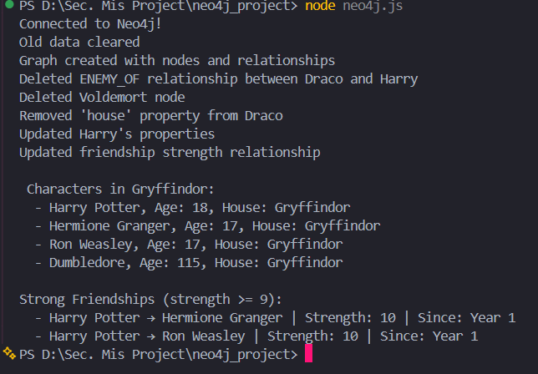

- go to neo4j desktop, to the instance, click at connect dropdown and choose query

to the query tab write this commands (line by line) to see the graph and the table:

MATCH (n)-[r]->(m) RETURN n, r, m

The result:
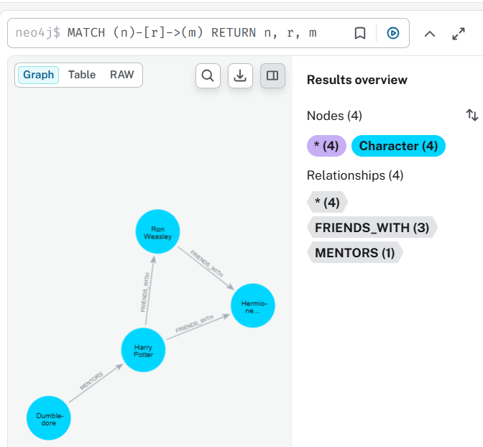

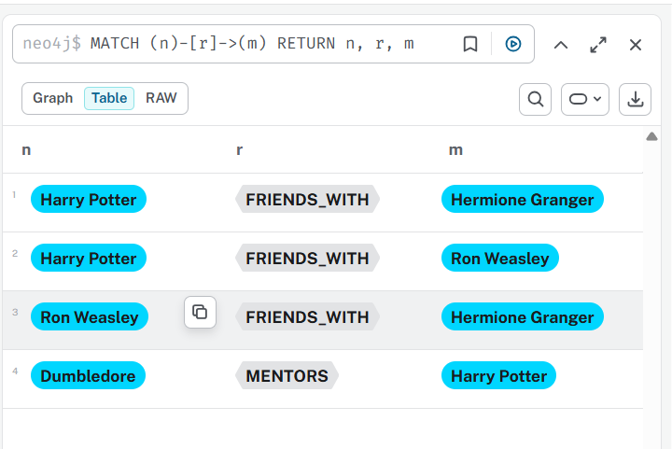

MATCH (c:Character) WHERE c.house = "Gryffindor" RETURN c

The result:

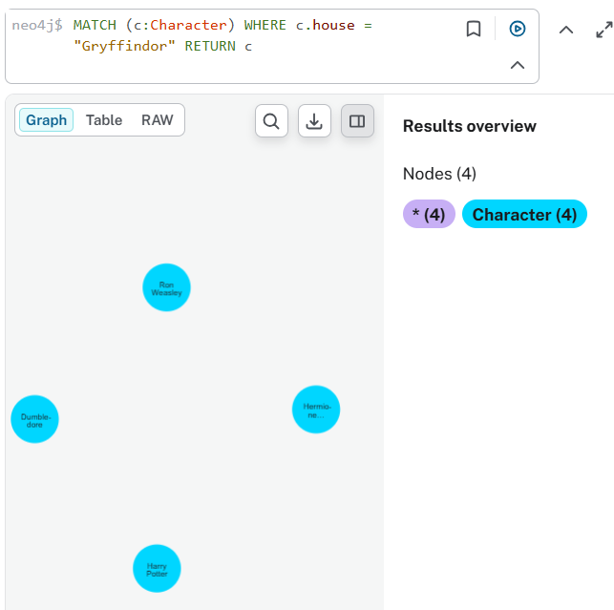
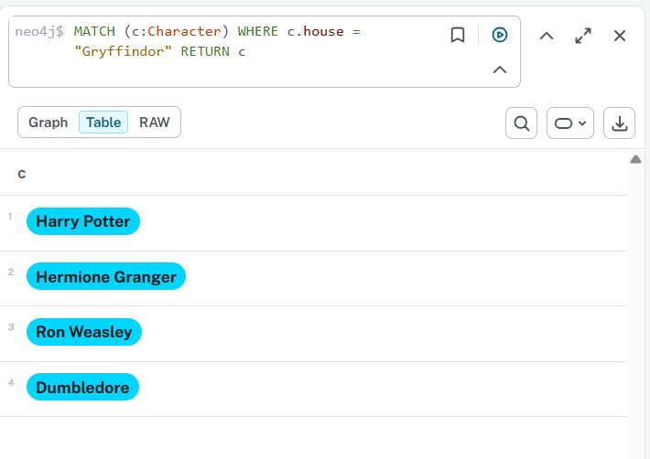

MATCH (a)-[r:MENTORS]->(b) RETURN a, r, b

The result:

